Serverless Architecture Documentation

Project Title
Serverless Data Processing Pipeline with AWS Lambda, S3, and DynamoDB

Objective
Design and implement a fully serverless pipeline that ingests data via S3, processes it using AWS Lambda, and stores transformed results in DynamoDB for querying and downstream use.

Architecture Overview
[S3 Bucket] → (Trigger) → [AWS Lambda] → [DynamoDB Table]
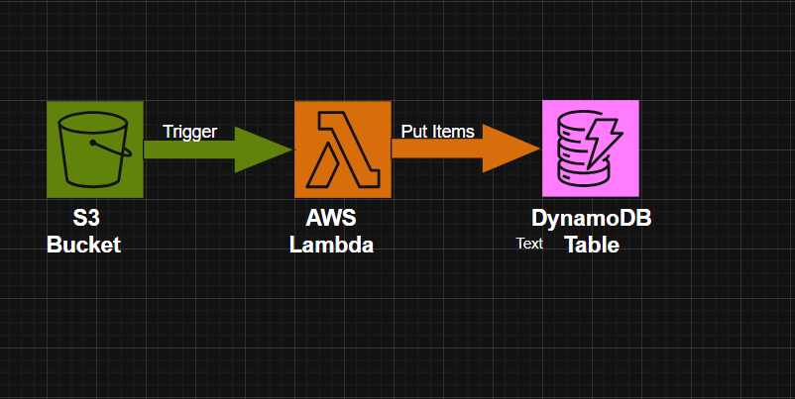
- S3 Bucket: Stores incoming `.csv` or `.json` files.
- Lambda Function: Triggered on file upload. Parses and transforms data using Python.
- DynamoDB: Stores processed records with partition/sort keys for efficient querying.

Workflow Steps
- Data Ingestion: Files uploaded to s3://your-bucket-name/input/ and triggers Lambda execution.
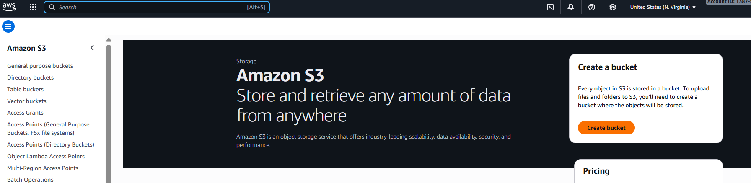

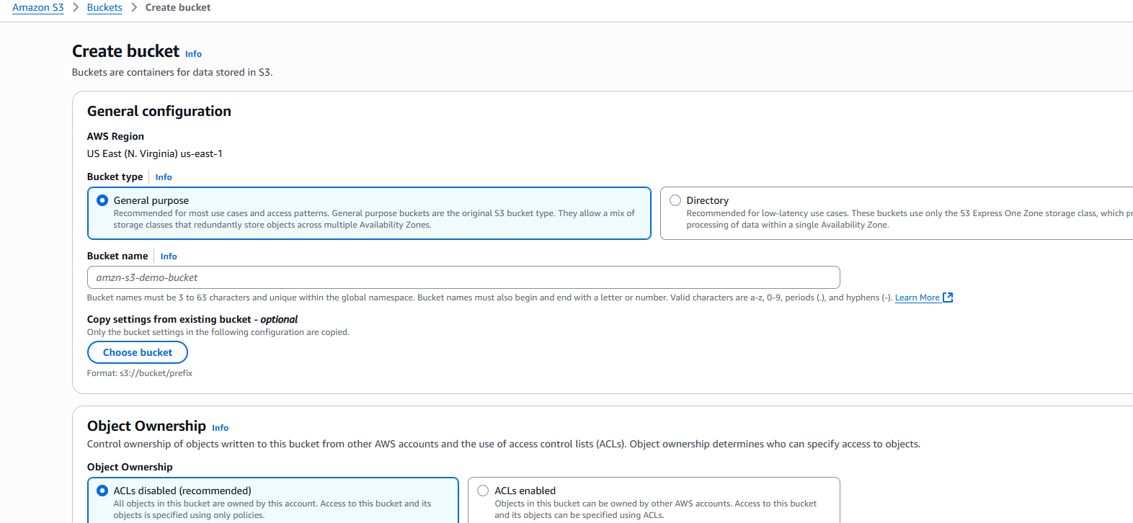
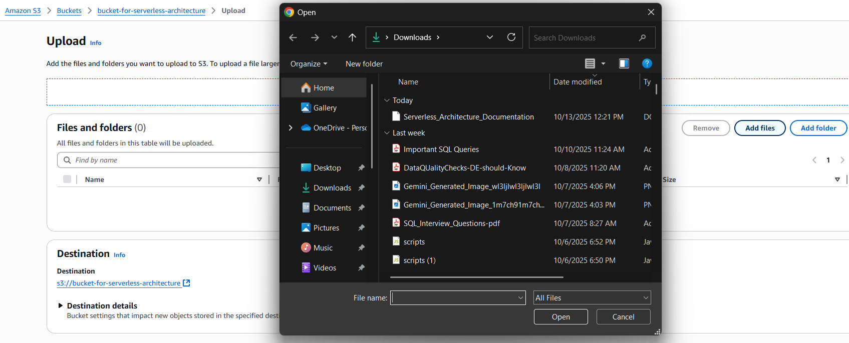

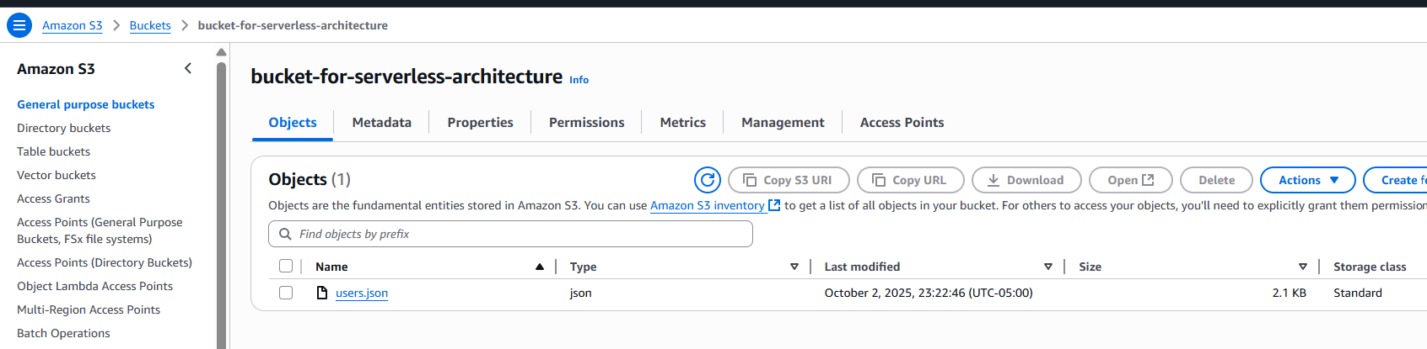
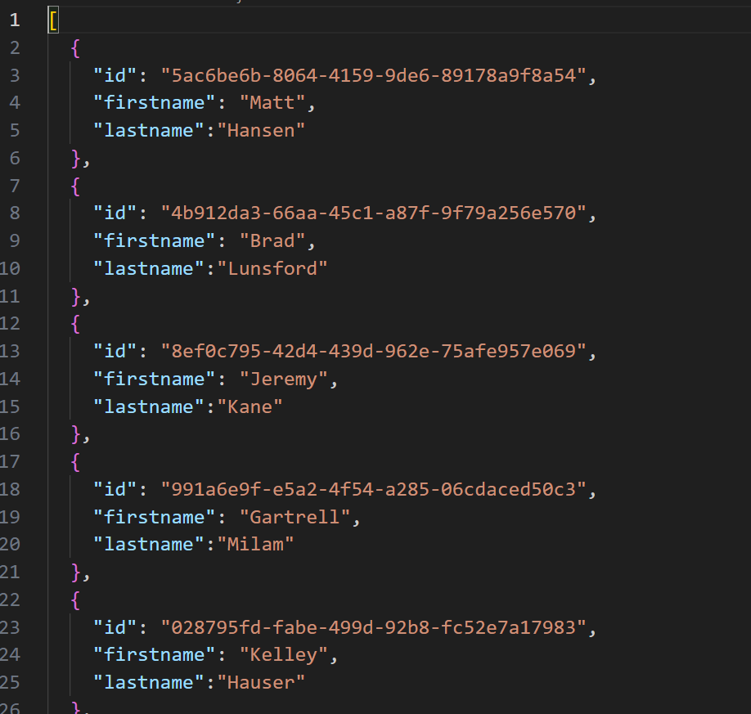

- Triggering:Configuring S3 Event Notification to Trigger Lambda
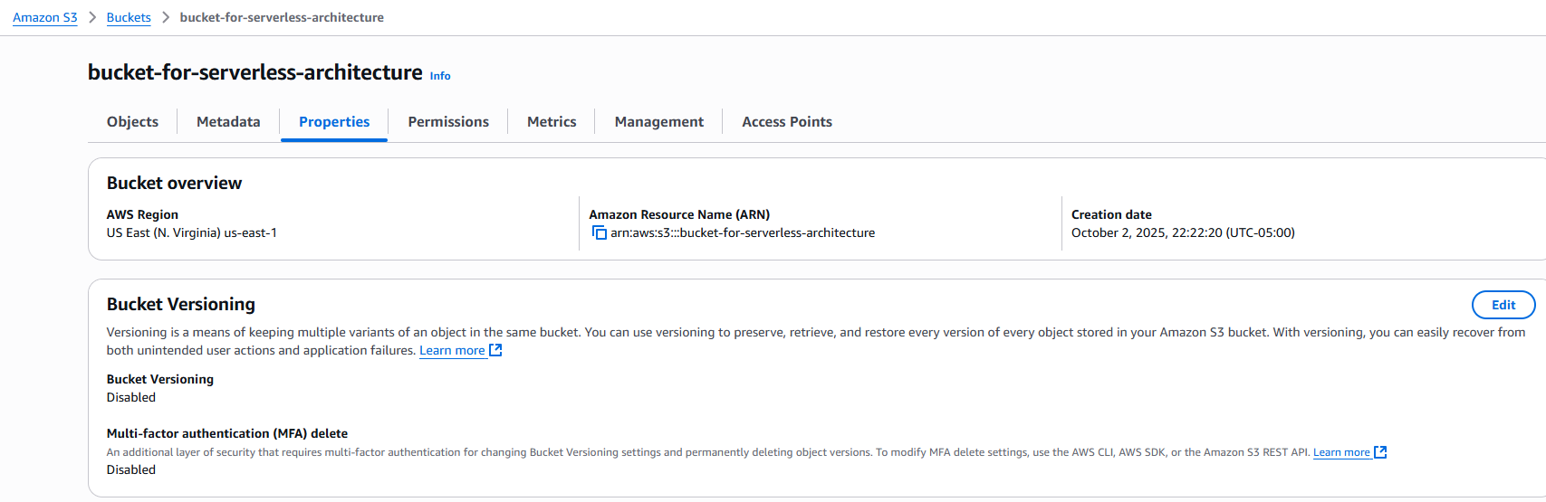

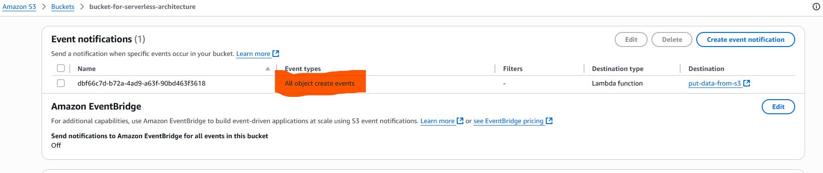

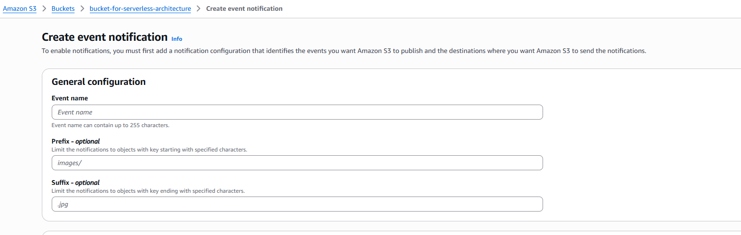

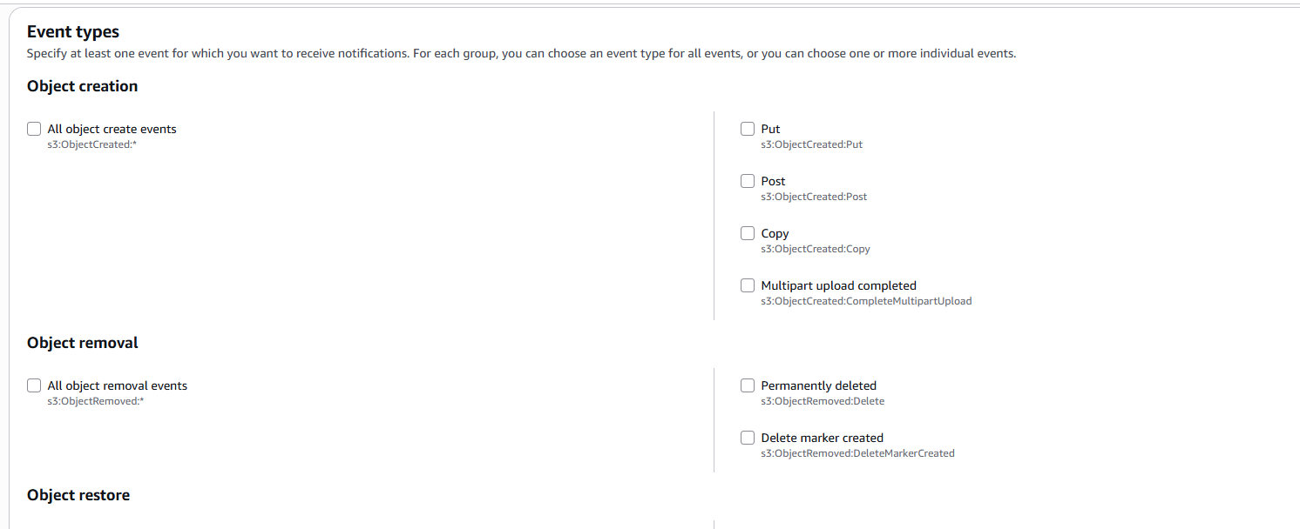

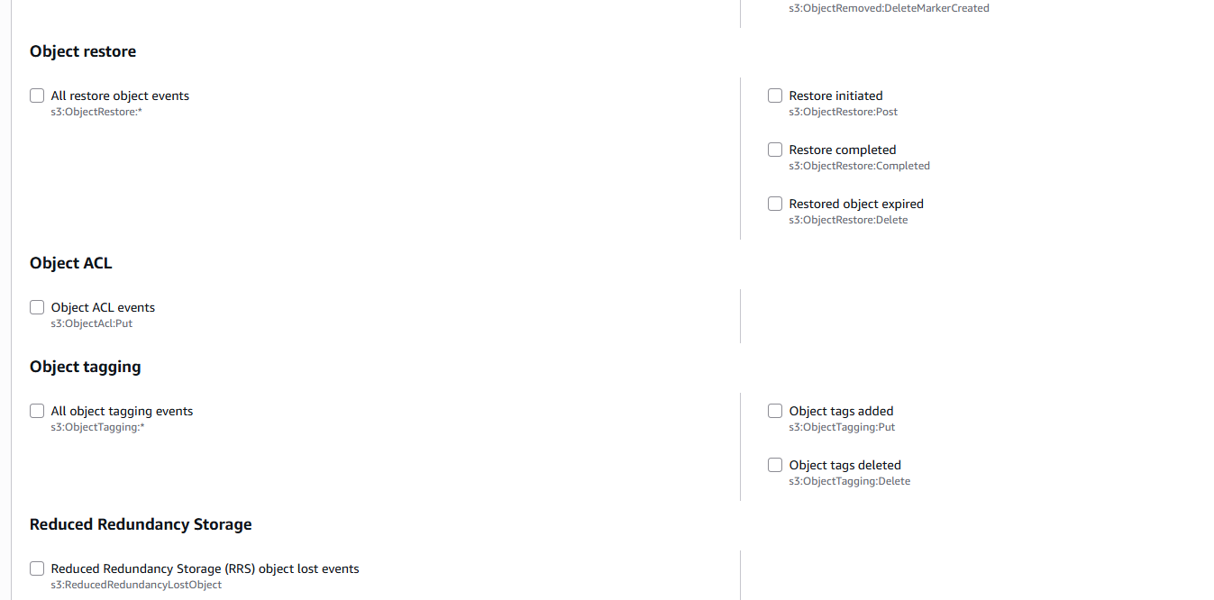

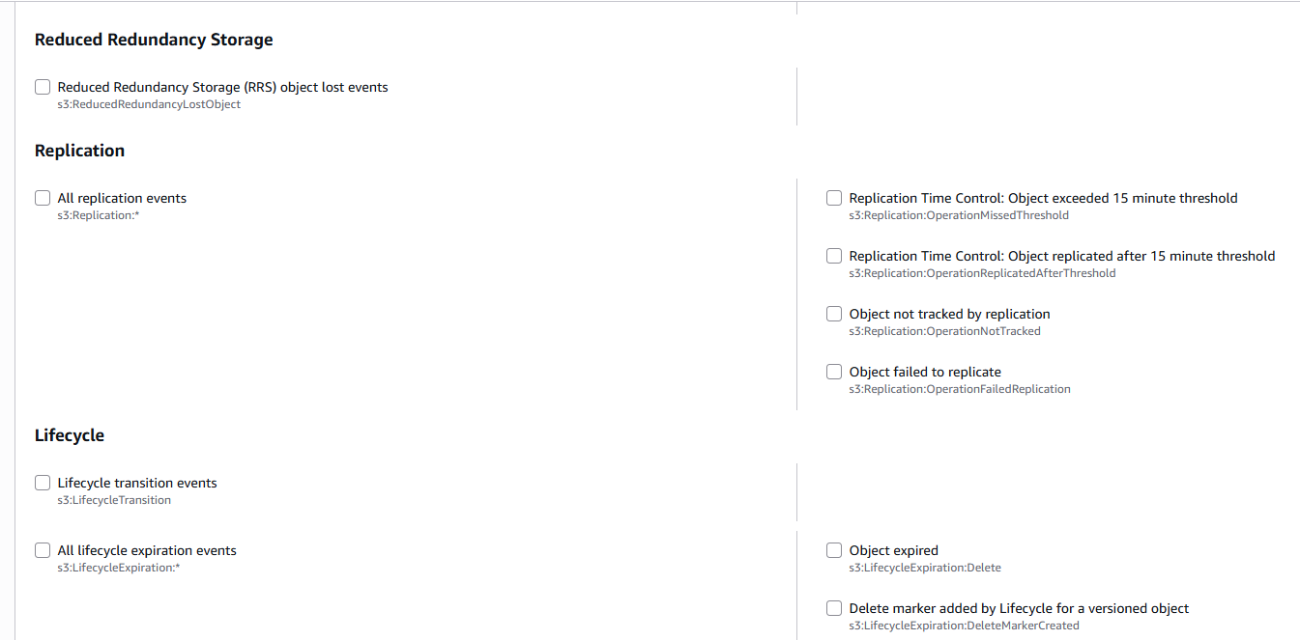

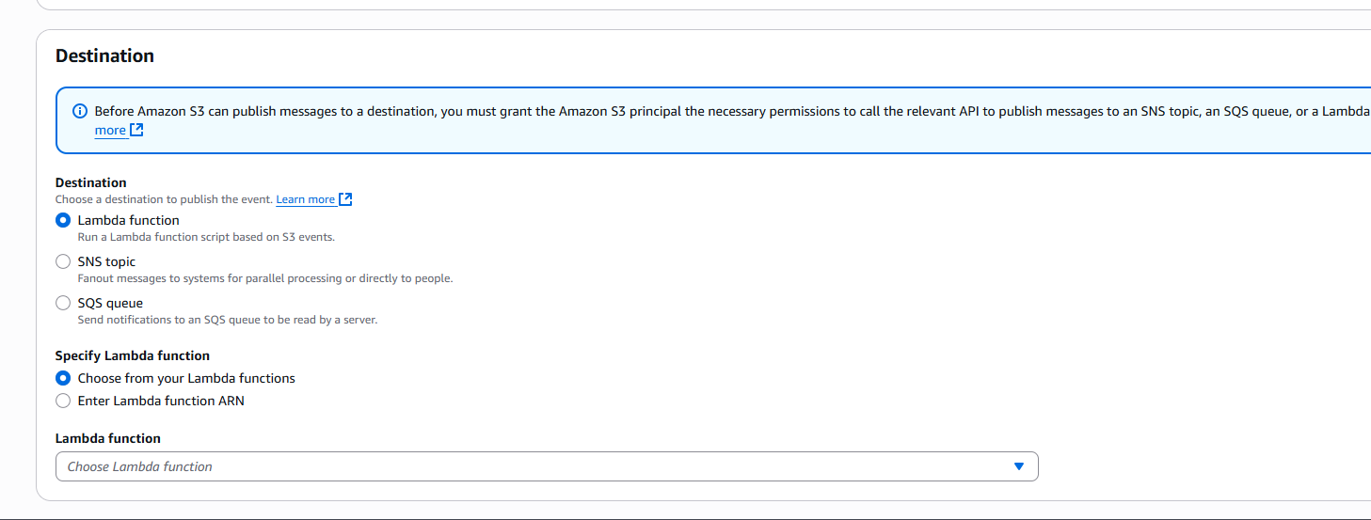



- Data Processing: Lambda reads file from S3, parses content using Python (csv/json/boto3), and applies transformations.
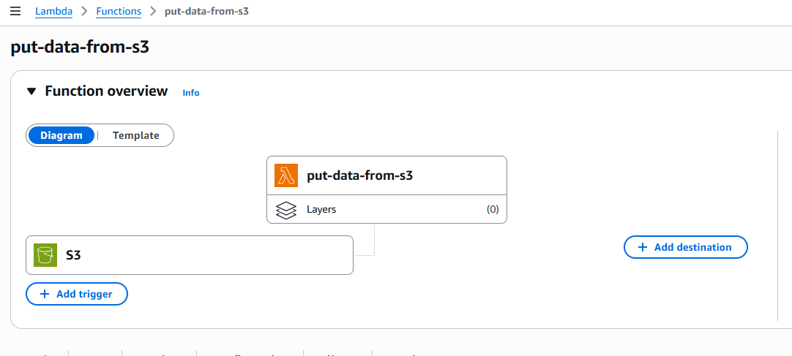

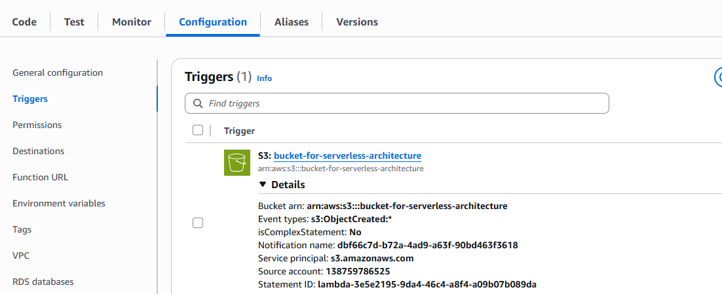

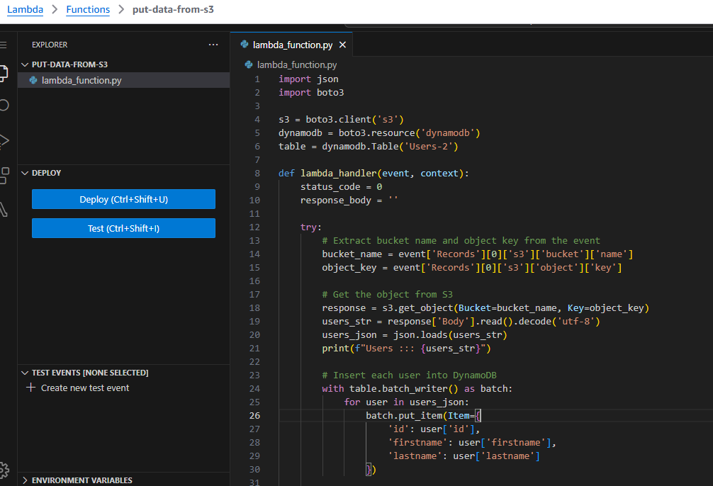

- Data Storage: Records are written to DynamoDB using PutItem or BatchWriteItem for efficiency.

DynamoDB Table Schema

Table Name
Users2

Primary Key Structure
Partition Key: user_id (String)
Sort Key (optional)

Attributes

Attribute | Type
id | String
firstname | String
lastname | String

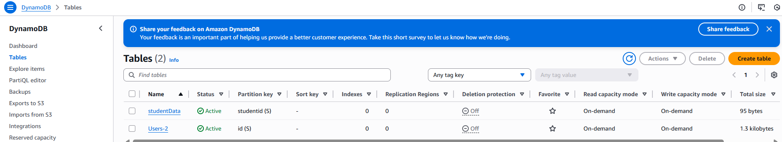
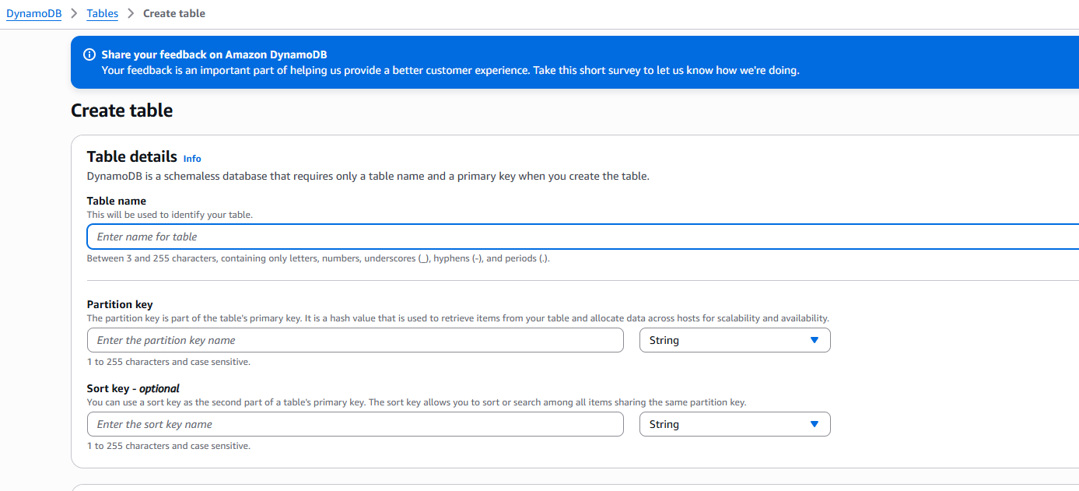
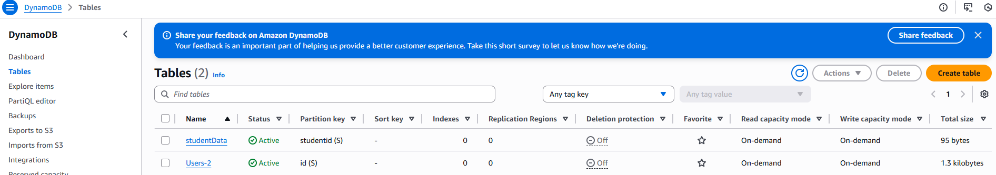

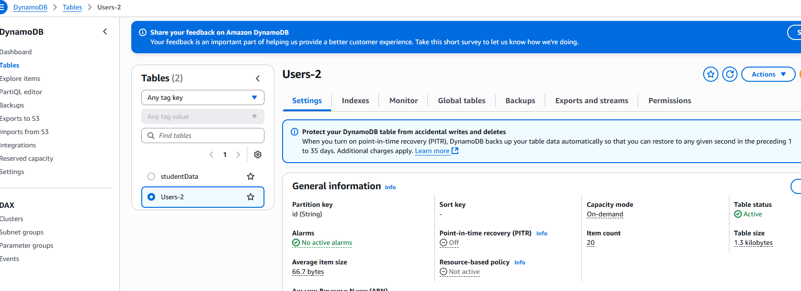

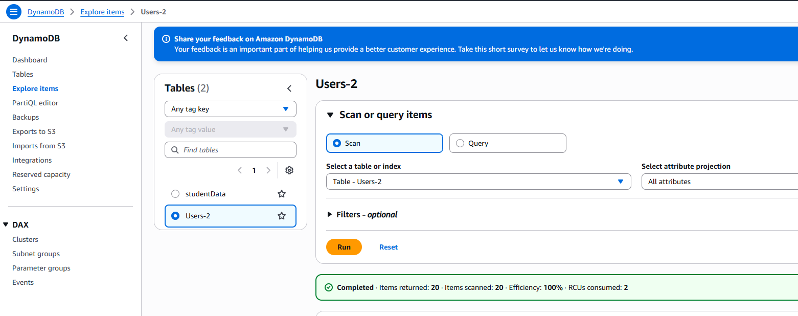

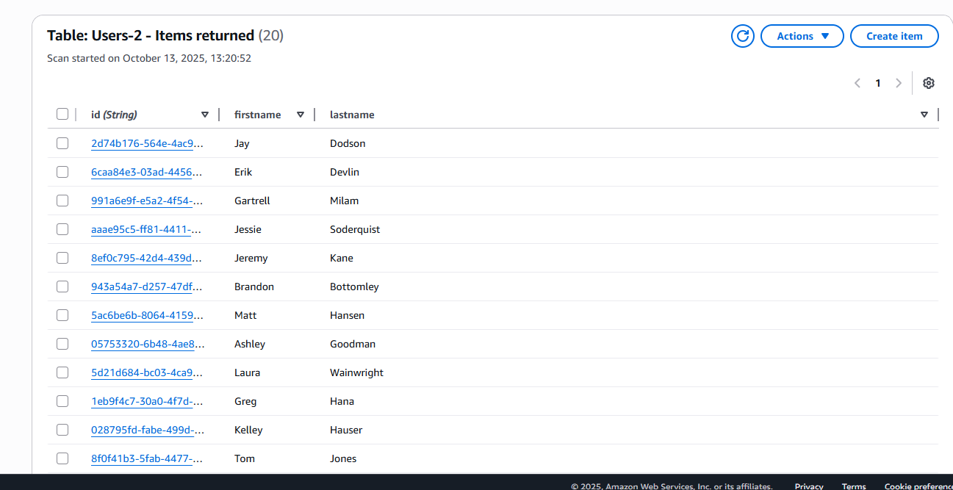

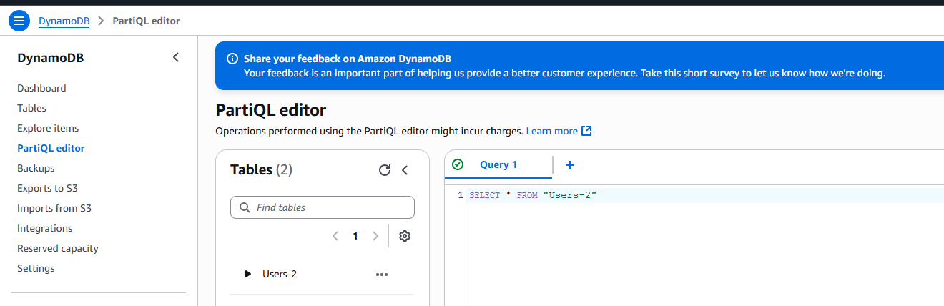

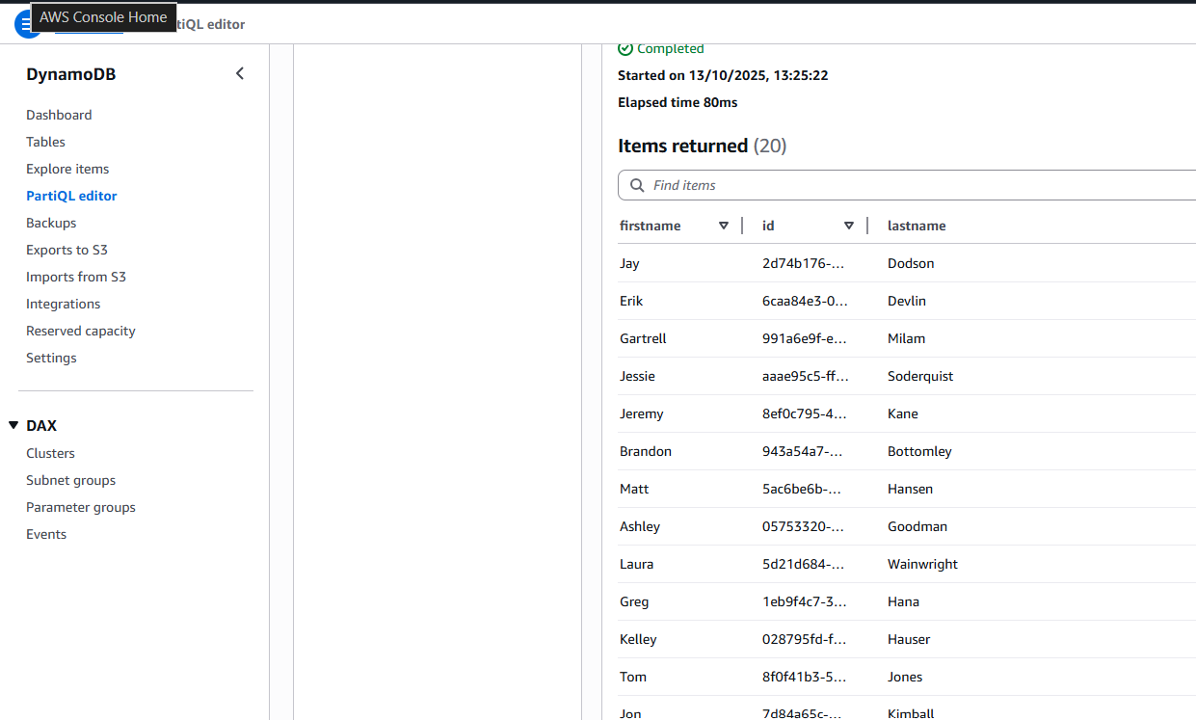

- Monitoring & Logging: CloudWatch logs and alarms for execution, failures, or throttling.

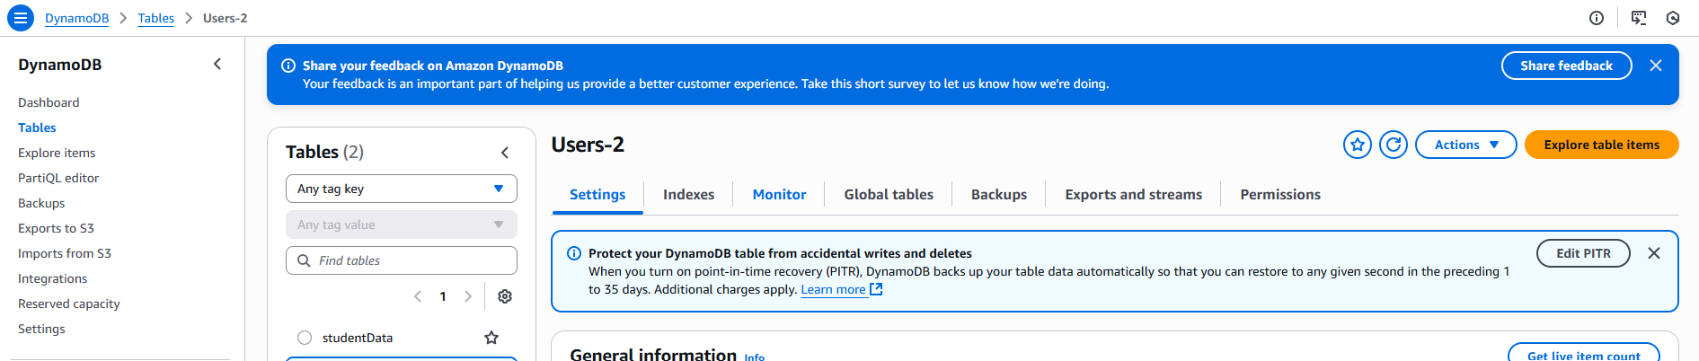

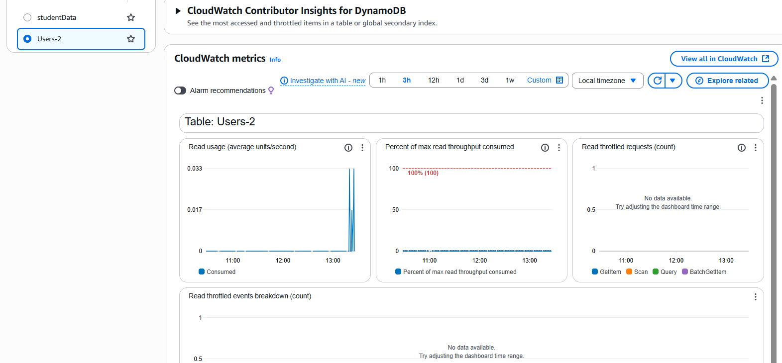

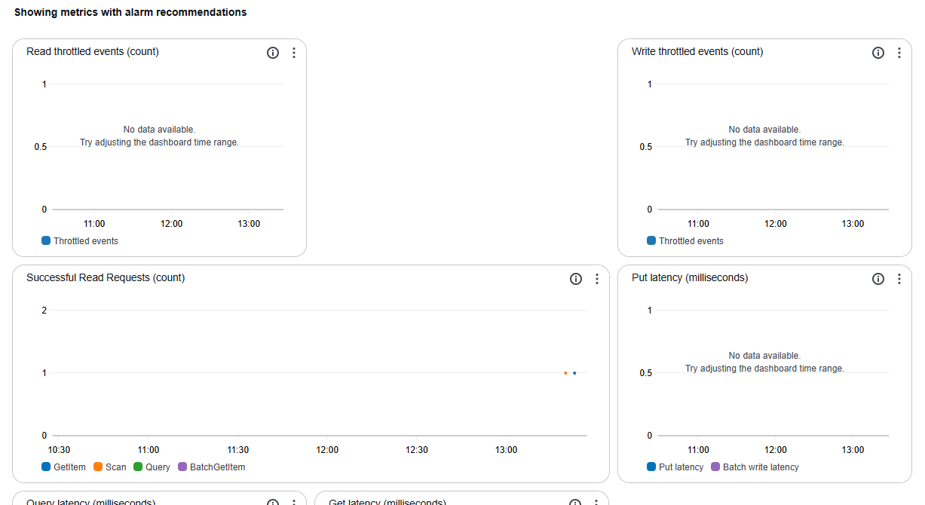

✅ Why Set RCU Alarms?
- Catch unexpected spikes in read traffic
- Avoid throttling that could affect downstream systems
- Demonstrate operational maturity in your architecture
- Support cost optimization by tracking usage trends

🔔 How to Set RCU Alarms in CloudWatch
Here’s a clean step-by-step you can document or implement:

1. Go to CloudWatch Console
- Navigate to Alarms → Create Alarm
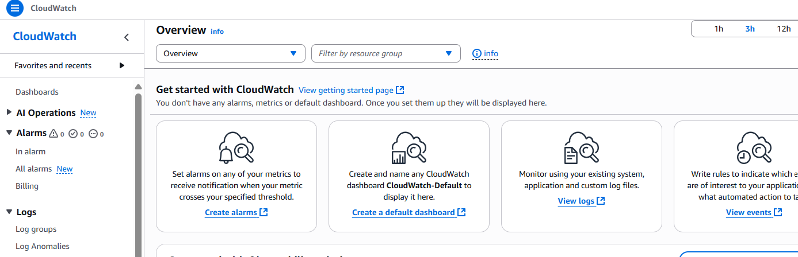

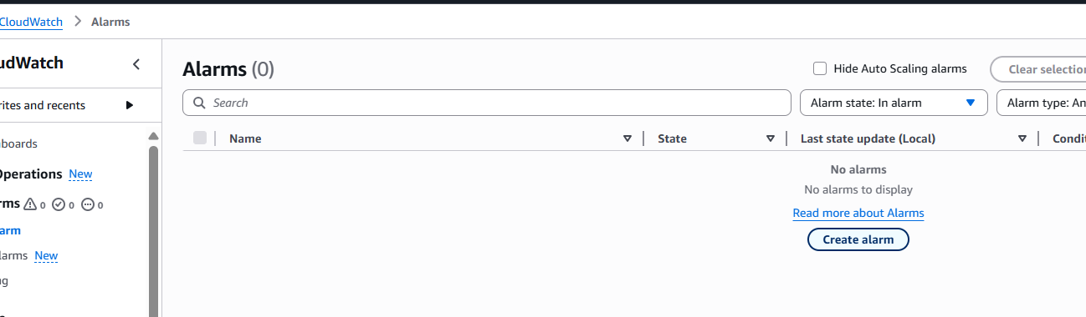

Select Metric

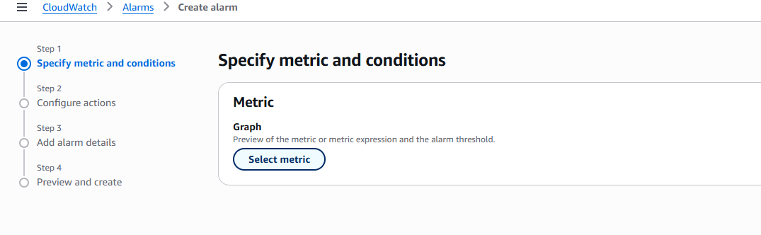
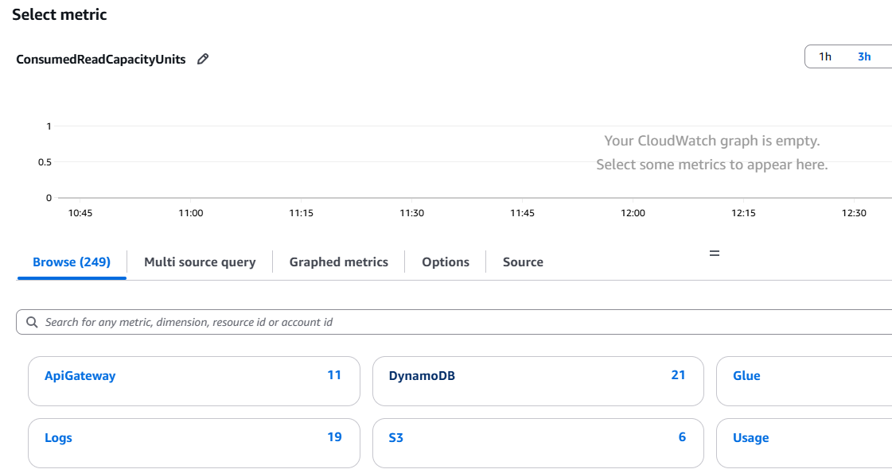
- Choose DynamoDB → Table Metrics
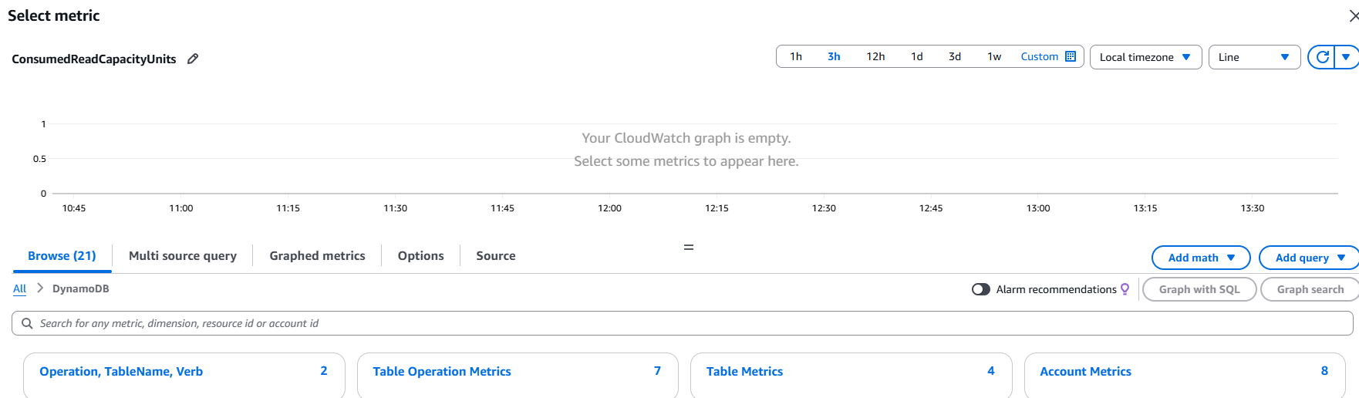
- Filter by your table name (e.g., ProcessedData)
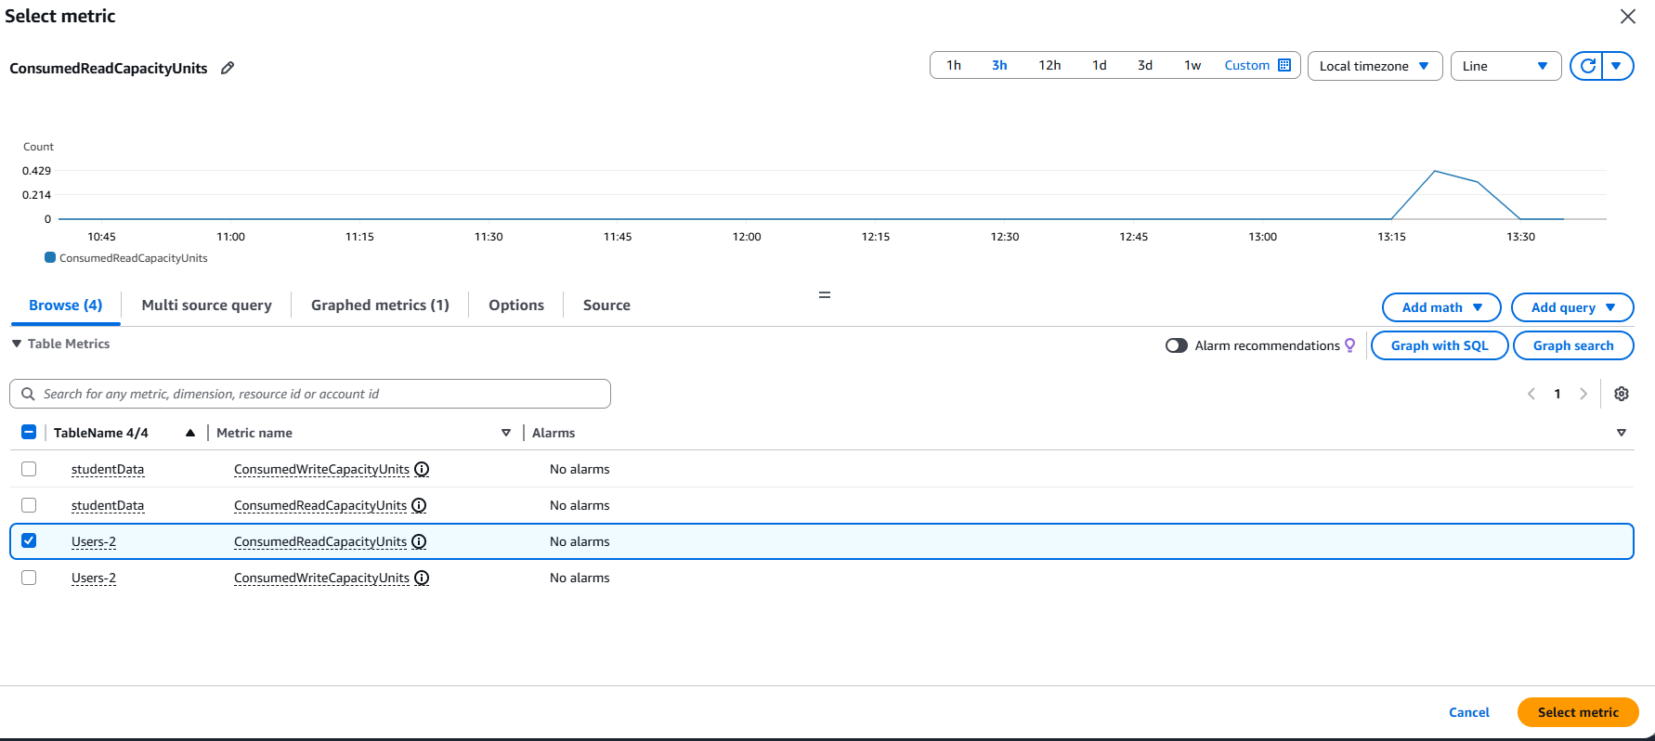
- Select ConsumedReadCapacityUnits
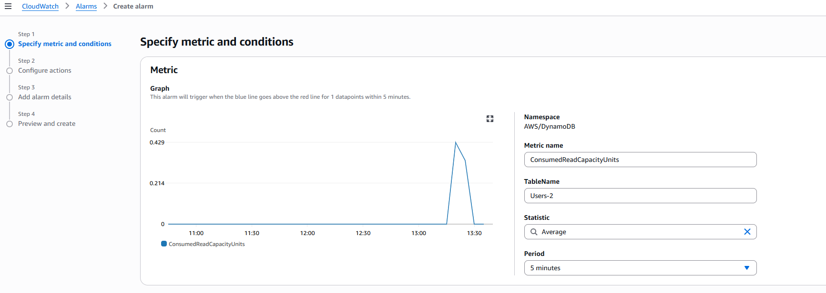

3. Define Threshold
- Example:
  - Threshold type: Static
  - Whenever RCU > 80 for 5 minutes
  - Adjust based on expected traffic
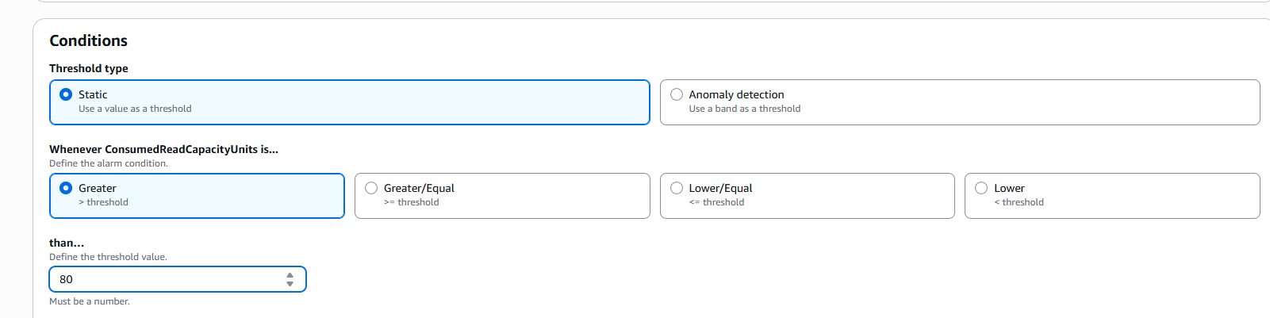

4. Set Notification
- Choose an SNS topic or create one (e.g., DynamoDBAlerts)
- Add your email or team notification channel
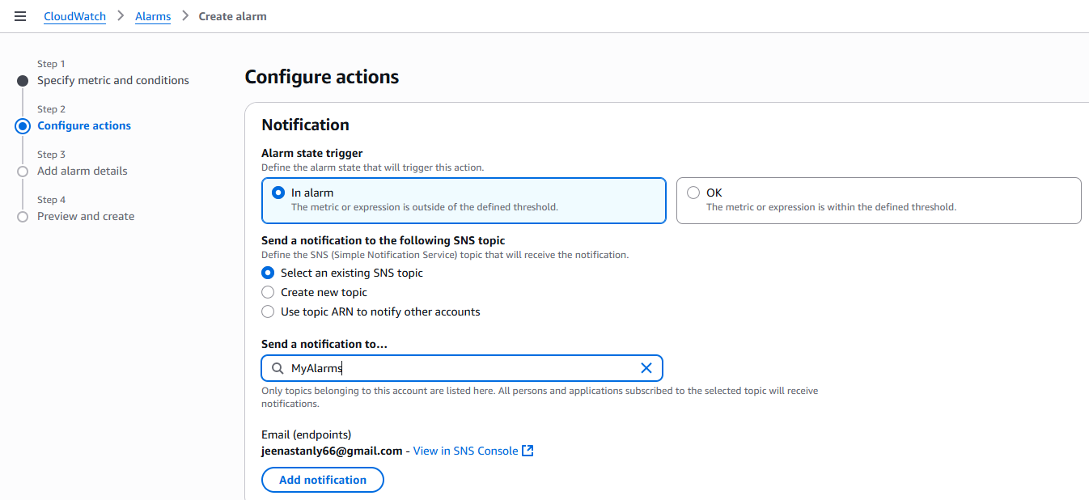

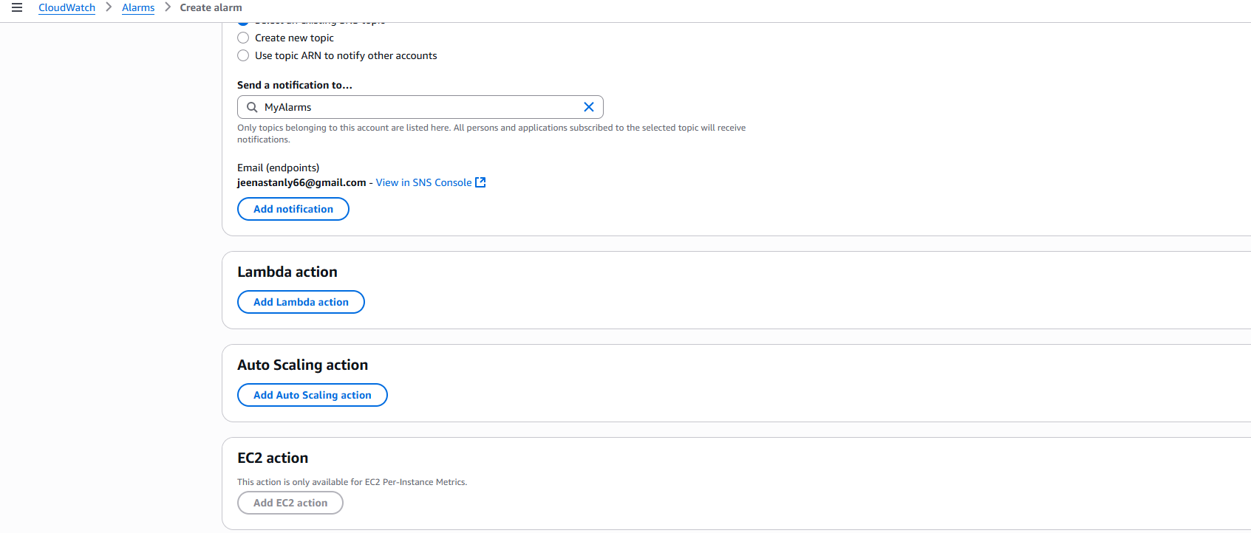

5. Name & Create
- Name: HighRCU_ProcessedData
- Review and create the alarm
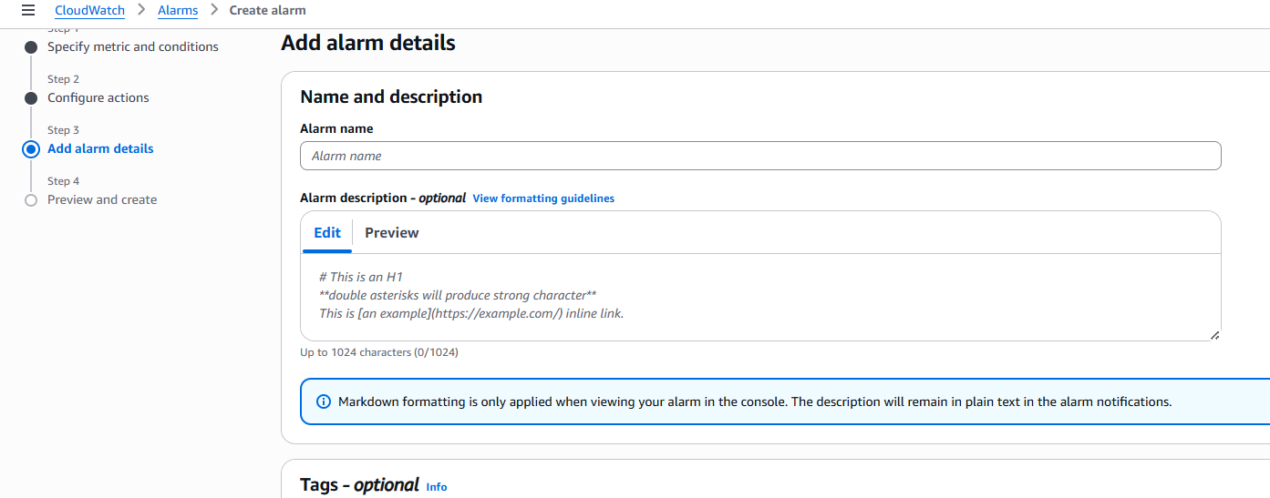
Alarm Name | Metric | Threshold | Action
HighRCU_ProcessedData | ConsumedReadCapacityUnits | > 80 for 5 min | Notify via SNS/email

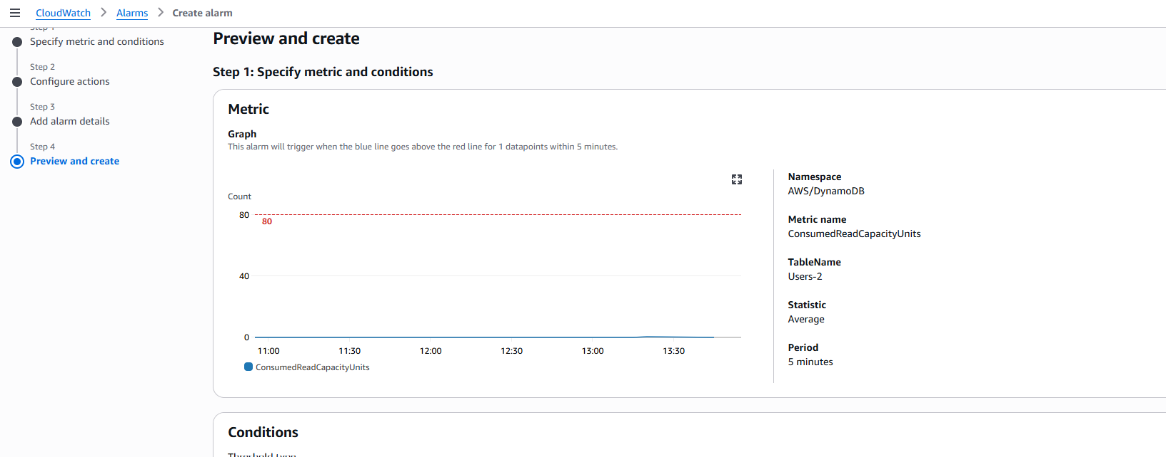

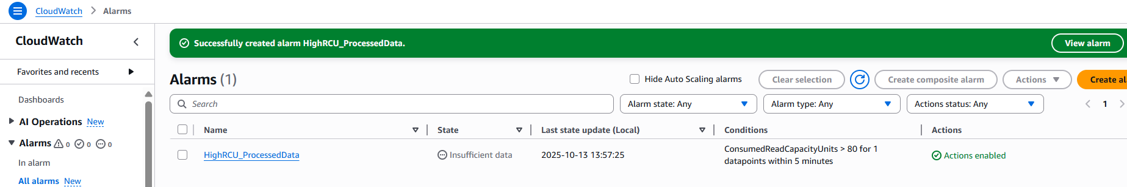

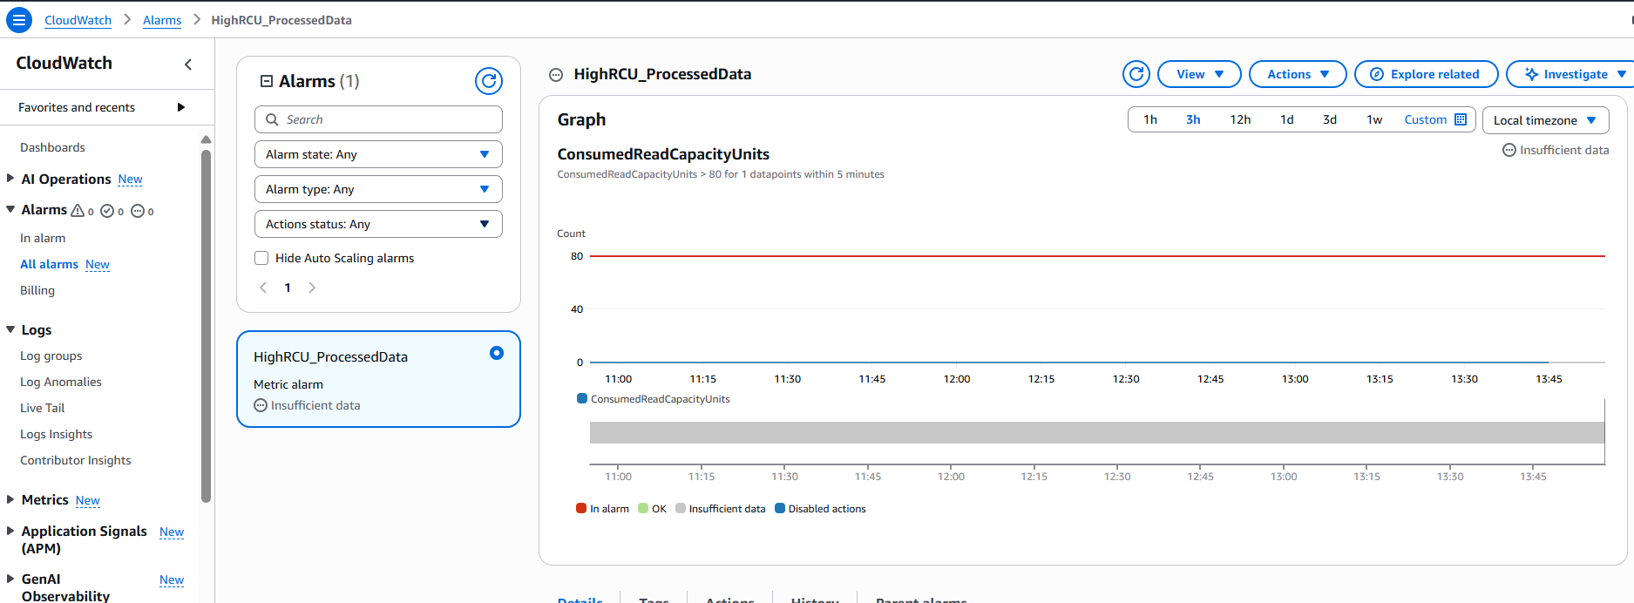

2. Lambda Function Documentation

Function Name
process_s3_file_to_dynamodb

Trigger
Event Source: S3
Event Type: ObjectCreated:*
Bucket: your-bucket-name

Runtime & Language
Python 3.13 - AWS Lambda

IAM Role Permissions
- s3:GetObject
- dynamodb:PutItem
- logs:CreateLogGroup
- logs:CreateLogStream
- logs:PutLogEvents

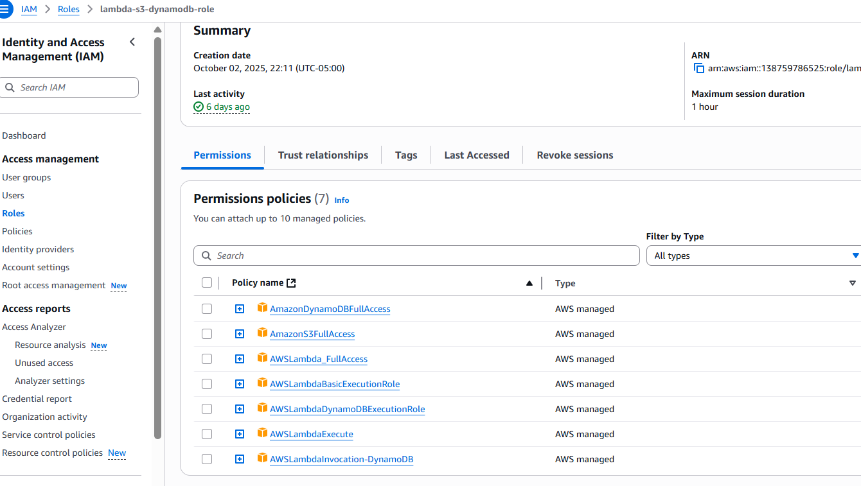

Code Summary
import json
import boto3

# Initialize AWS clients outside the handler for reusability and performance
s3 = boto3.client('s3')
dynamodb = boto3.resource('dynamodb')
table = dynamodb.Table('Users-2')

def lambda_handler(event, context):
"""
Lambda entry point triggered by S3 file upload.
Parses user data from the uploaded JSON file and stores it in DynamoDB.
"""
status_code = 0
response_body = ''

try:
# Extract bucket name and object key from the S3 event payload
bucket_name = event['Records'][0]['s3']['bucket']['name']
object_key = event['Records'][0]['s3']['object']['key']

# Retrieve the uploaded file from S3
response = s3.get_object(Bucket=bucket_name, Key=object_key)
file_content = response['Body'].read().decode('utf-8')

# Parse JSON content into Python list of user dictionaries
users = json.loads(file_content)
print(f"Parsed Users: {users}")

# Batch write user records to DynamoDB for efficiency
with table.batch_writer() as batch:
for user in users:
batch.put_item(Item={
'id': user['id'], # Unique identifier
'firstname': user['firstname'],
'lastname': user['lastname']
})

response_body = 'Successfully added users to DynamoDB.'
status_code = 201

except Exception as e:
# Log error and return failure response
print(f"Error processing file: {str(e)}")
response_body = 'Failed to add users to DynamoDB.'
status_code = 403

# Return HTTP-style response for Lambda integrations
return {
'statusCode': status_code,
'body': response_body
}

